Project Design Phase
Solution Architecture
Date | 12 July 2026
Team ID | Geeta Rani
Project Name | ShopEZ
Maximum Marks | 4 Marks

Solution Architecture
The ShopEZ application utilizes a 3-layer MERN architecture comprising React, Express, and MongoDB. Customers can browse the product catalog, manage a shopping cart, register or log in, and view their profile. JWT is employed in the authentication process, with data such as user accounts stored in MongoDB, while the product catalog is served from the application layer.

Solution Architecture Diagram:
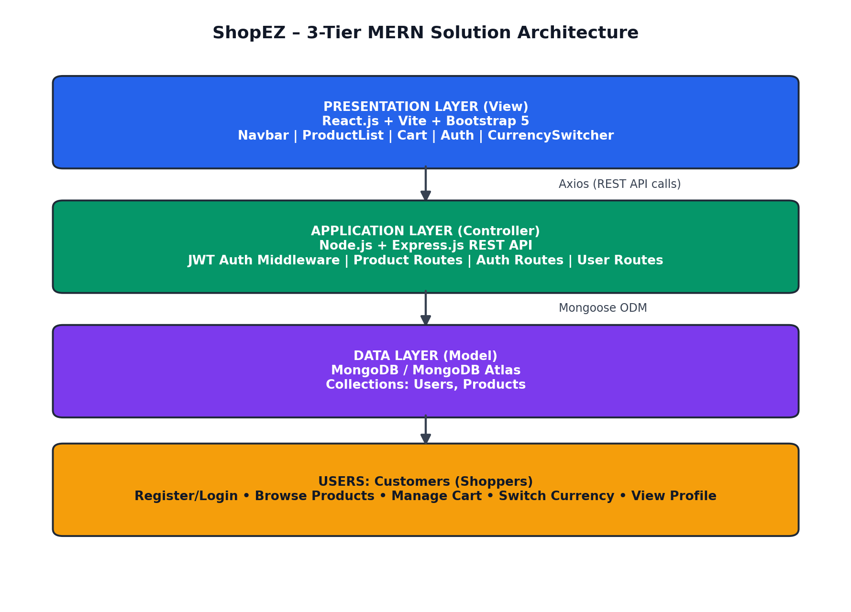
The proposed ShopEZ solution architecture uses a three-tier MERN stack along with an MVC (Model View Controller) pattern to keep the front-end, back-end, and database layers clearly separated. The front-end, built with React.js and powered by Vite, forms the View layer, where customers interact with the Navbar, ProductList, Cart, Auth, and CurrencySwitcher components rendered through Bootstrap 5.
The Node.js & Express.js REST API server acts as the controller and handles all requests received from the client using Axios HTTP calls. Protected routes, such as fetching the logged-in user's profile, are secured using JWT Authentication Middleware. Depending on the request, it is routed to the appropriate handler for authentication (register, login, profile) or product retrieval.
The controllers interact with the database using Mongoose ODM to perform CRUD operations on the User collection, while the product catalog is served from an in-memory data set representing the Product model. These constitute the Model layer and determine the structure of the application's data. The database processes requests and returns responses that are rendered by the frontend interface. Using this MVC-based MERN architecture, ShopEZ can be built to be secure, scalable, and capable of efficiently managing product browsing, cart activity, and customer accounts.

